Contents
1. Create database 1
Create database by using statement. 1
Create database by graphic tool 1
Create database by using a template 3
2. Rename a database 6
Rename database by using statement 6
Rename database by graphic tool 6
3. Drop a database 7
Drop database by using statement 7
Drop database by using graphic tool. 7

Create database
We can create a database by one of following way:

Create database by using statement.
- In the SSMS enters following statement and clicks Execute. A database named Fsoft_Training will be created.
CREATE DATABASE Fsoft_Training

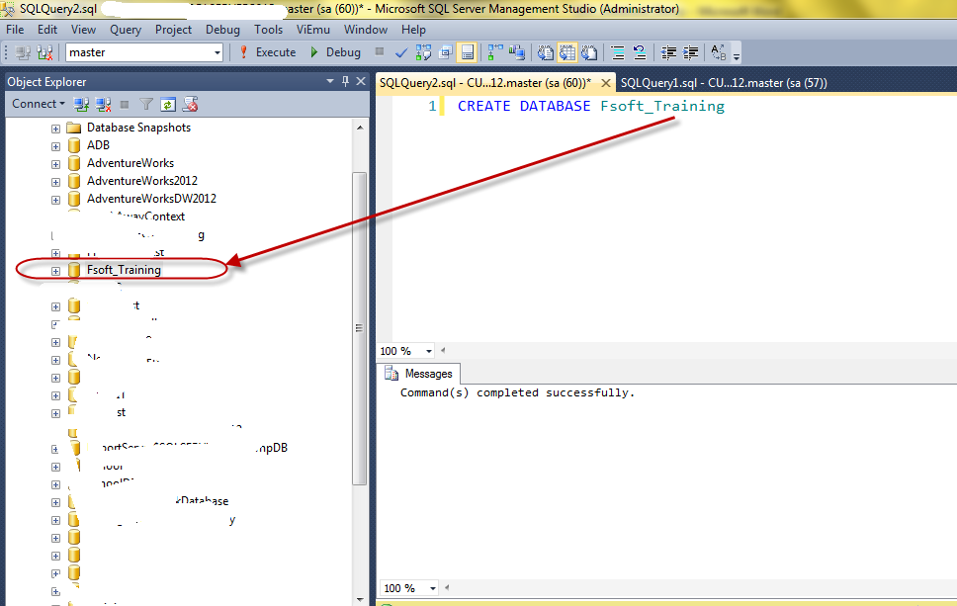

Create database by graphic tool
- In Object Explorer, right clicks on Database and choose New Database...
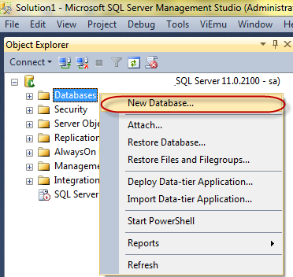
- In the New Database dialog, enter Fsoft_Training in the Database name textbox.
We can change location for mdf and ldf file in database files
Each database has at least one mdf file
ldf file is a transaction log file. In real world, we should store mdf and ldf in the separate hard disk drive.
Click OK button to create the database
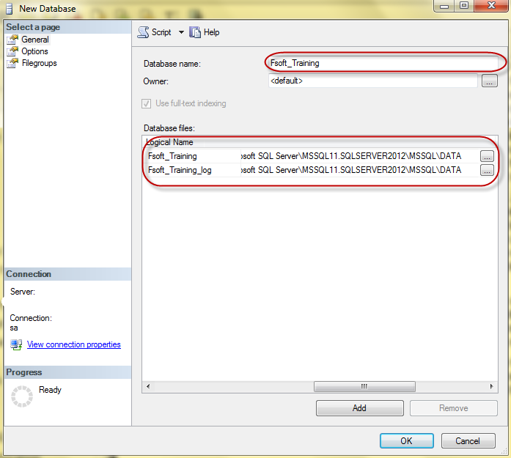

Create database by using a template
- Choose Template Explorer in the View menu
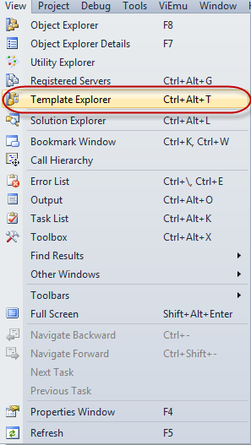
- Double click on Create Database under Database folder
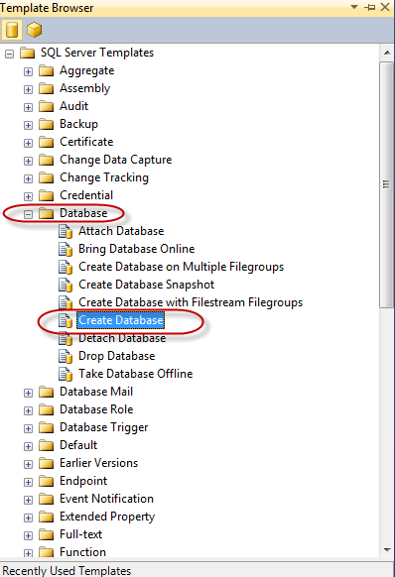
- Just enter database name in the script and run Execute as below
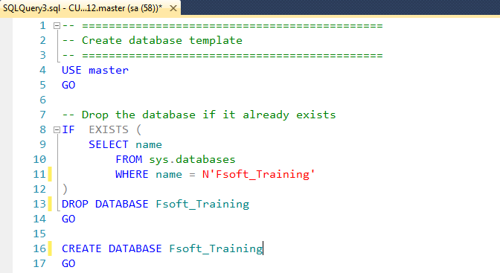

2. Rename a database

Rename database by using statement
- Use the below statement in order to rename the database.
USE master;
GO
ALTER DATABASE Fsoft_Training
Modify Name = Fsoft_Training2 ;
GO

Rename database by graphic tool
- In the Object Explorer, right click on the database and choose Rename
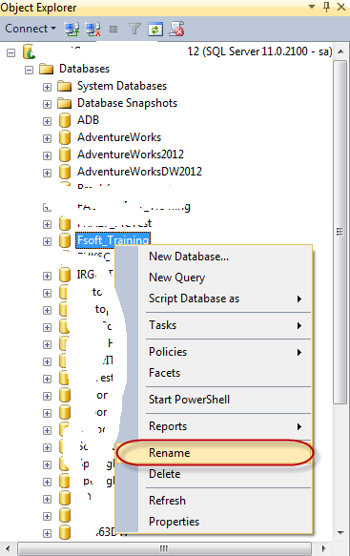

3. Drop a database

Drop database by using statement
- Copy and Paste below statement and click Execute
USE master
GO
DROP DATABASE Fsoft_Training
GO

Drop database by using graphic tool.
- Right click on the database and choose Delete
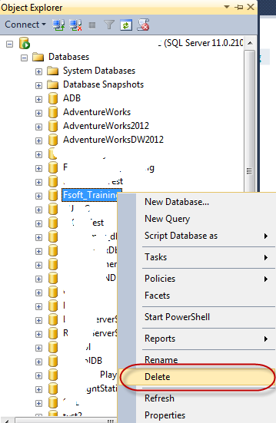
- In the Delete Object dialog, make sure Close existing connections is checked and then click OK
